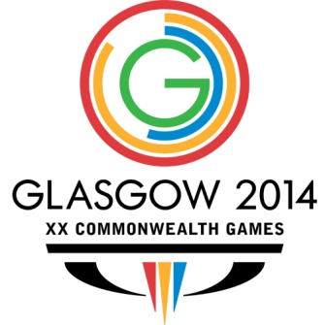

**India lost to England in Mixed Team Event Semis: CWG 2014**

**India, after losing to England in the Semifinals, will now attempt to win the Bronze Medal when they clash with Singapore, who lost 2-3 to Malaysia.**

[Press Trust of India :](http://sports.ndtv.com/authors/195-press-trust-of-india) July 28, 2014

Glasgow: Star players Parupalli Kashyap and Jwala Gutta failed to create magic as India were blanked 0-3 by a dominant England in the  Mixed Team Semifinals of Badminton competitions at the Commonwealth Games, here on Sunday.

Jwala and Akshay Dewalkar began India's campaign but could not put the country ahead, losing Mixed Doubles 16-21, 21-16, 11-21 to the British combination of Chris Adcock and Gabrielle Adcock in 52 minutes.

India needed Kashyap, Silver Medalist at 2010 Games, to level the contest but he went down fighting 16-21 19-21 to Rajiv Ouseph in the singles in 47 minutes in the second match.

Akshay and Pranav Chopra then lost the crunch Men's Doubles match 21-12 13-21, 16-21 to Chris and Andrew Ellis, ending all Indian hopes.

India will now attempt to win the Bronze Medal when they clash with Singapore, who lost 2-3 to Malaysia.

-------------------------------